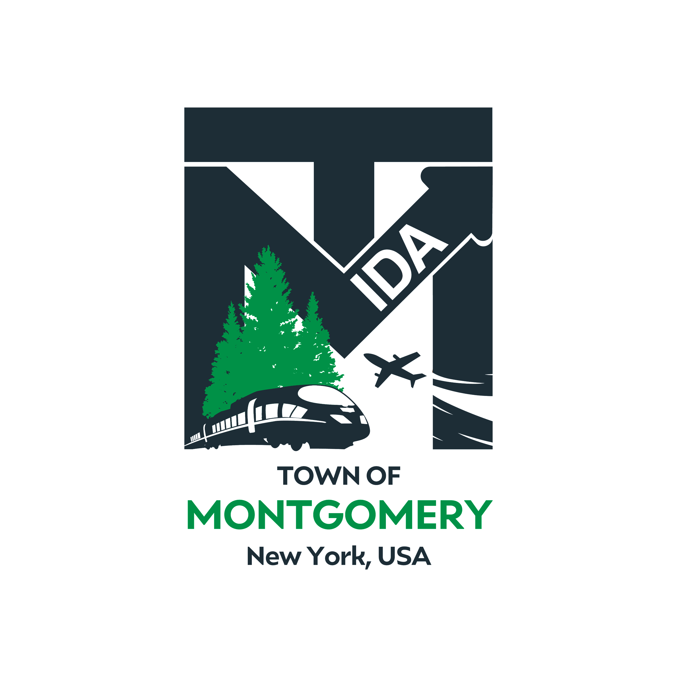
Draft Agenda Subject to Change
REGULAR MEETING OF THE
TOWN OF MONTGOMERY INDUSTRIAL DEVELOPMENT AGENCY
110 Bracken Road
Montgomery, New York 12549
www.montgomeryida.com
(845) 457-2600
Tuesday, January 11th

AGENDA
1:00 PM
- Call to Order and Declaration of Quorum
- Approval of the December 14, 2021 Meeting Minutes
- Public Comment on Items on the Agenda
- Annual Reorganization Resolution: Consideration for Approval
- Executive Director’s Report
- Financial Report
- Other Business
- Adjournment
- Next Meeting Scheduled for February 8, 2022

The meeting shall be live-streamed and be available for viewing at the following sites: https://acquisitionsmarketing.com/
https://www.facebook.com/TownofMontgomeryOfficial/

