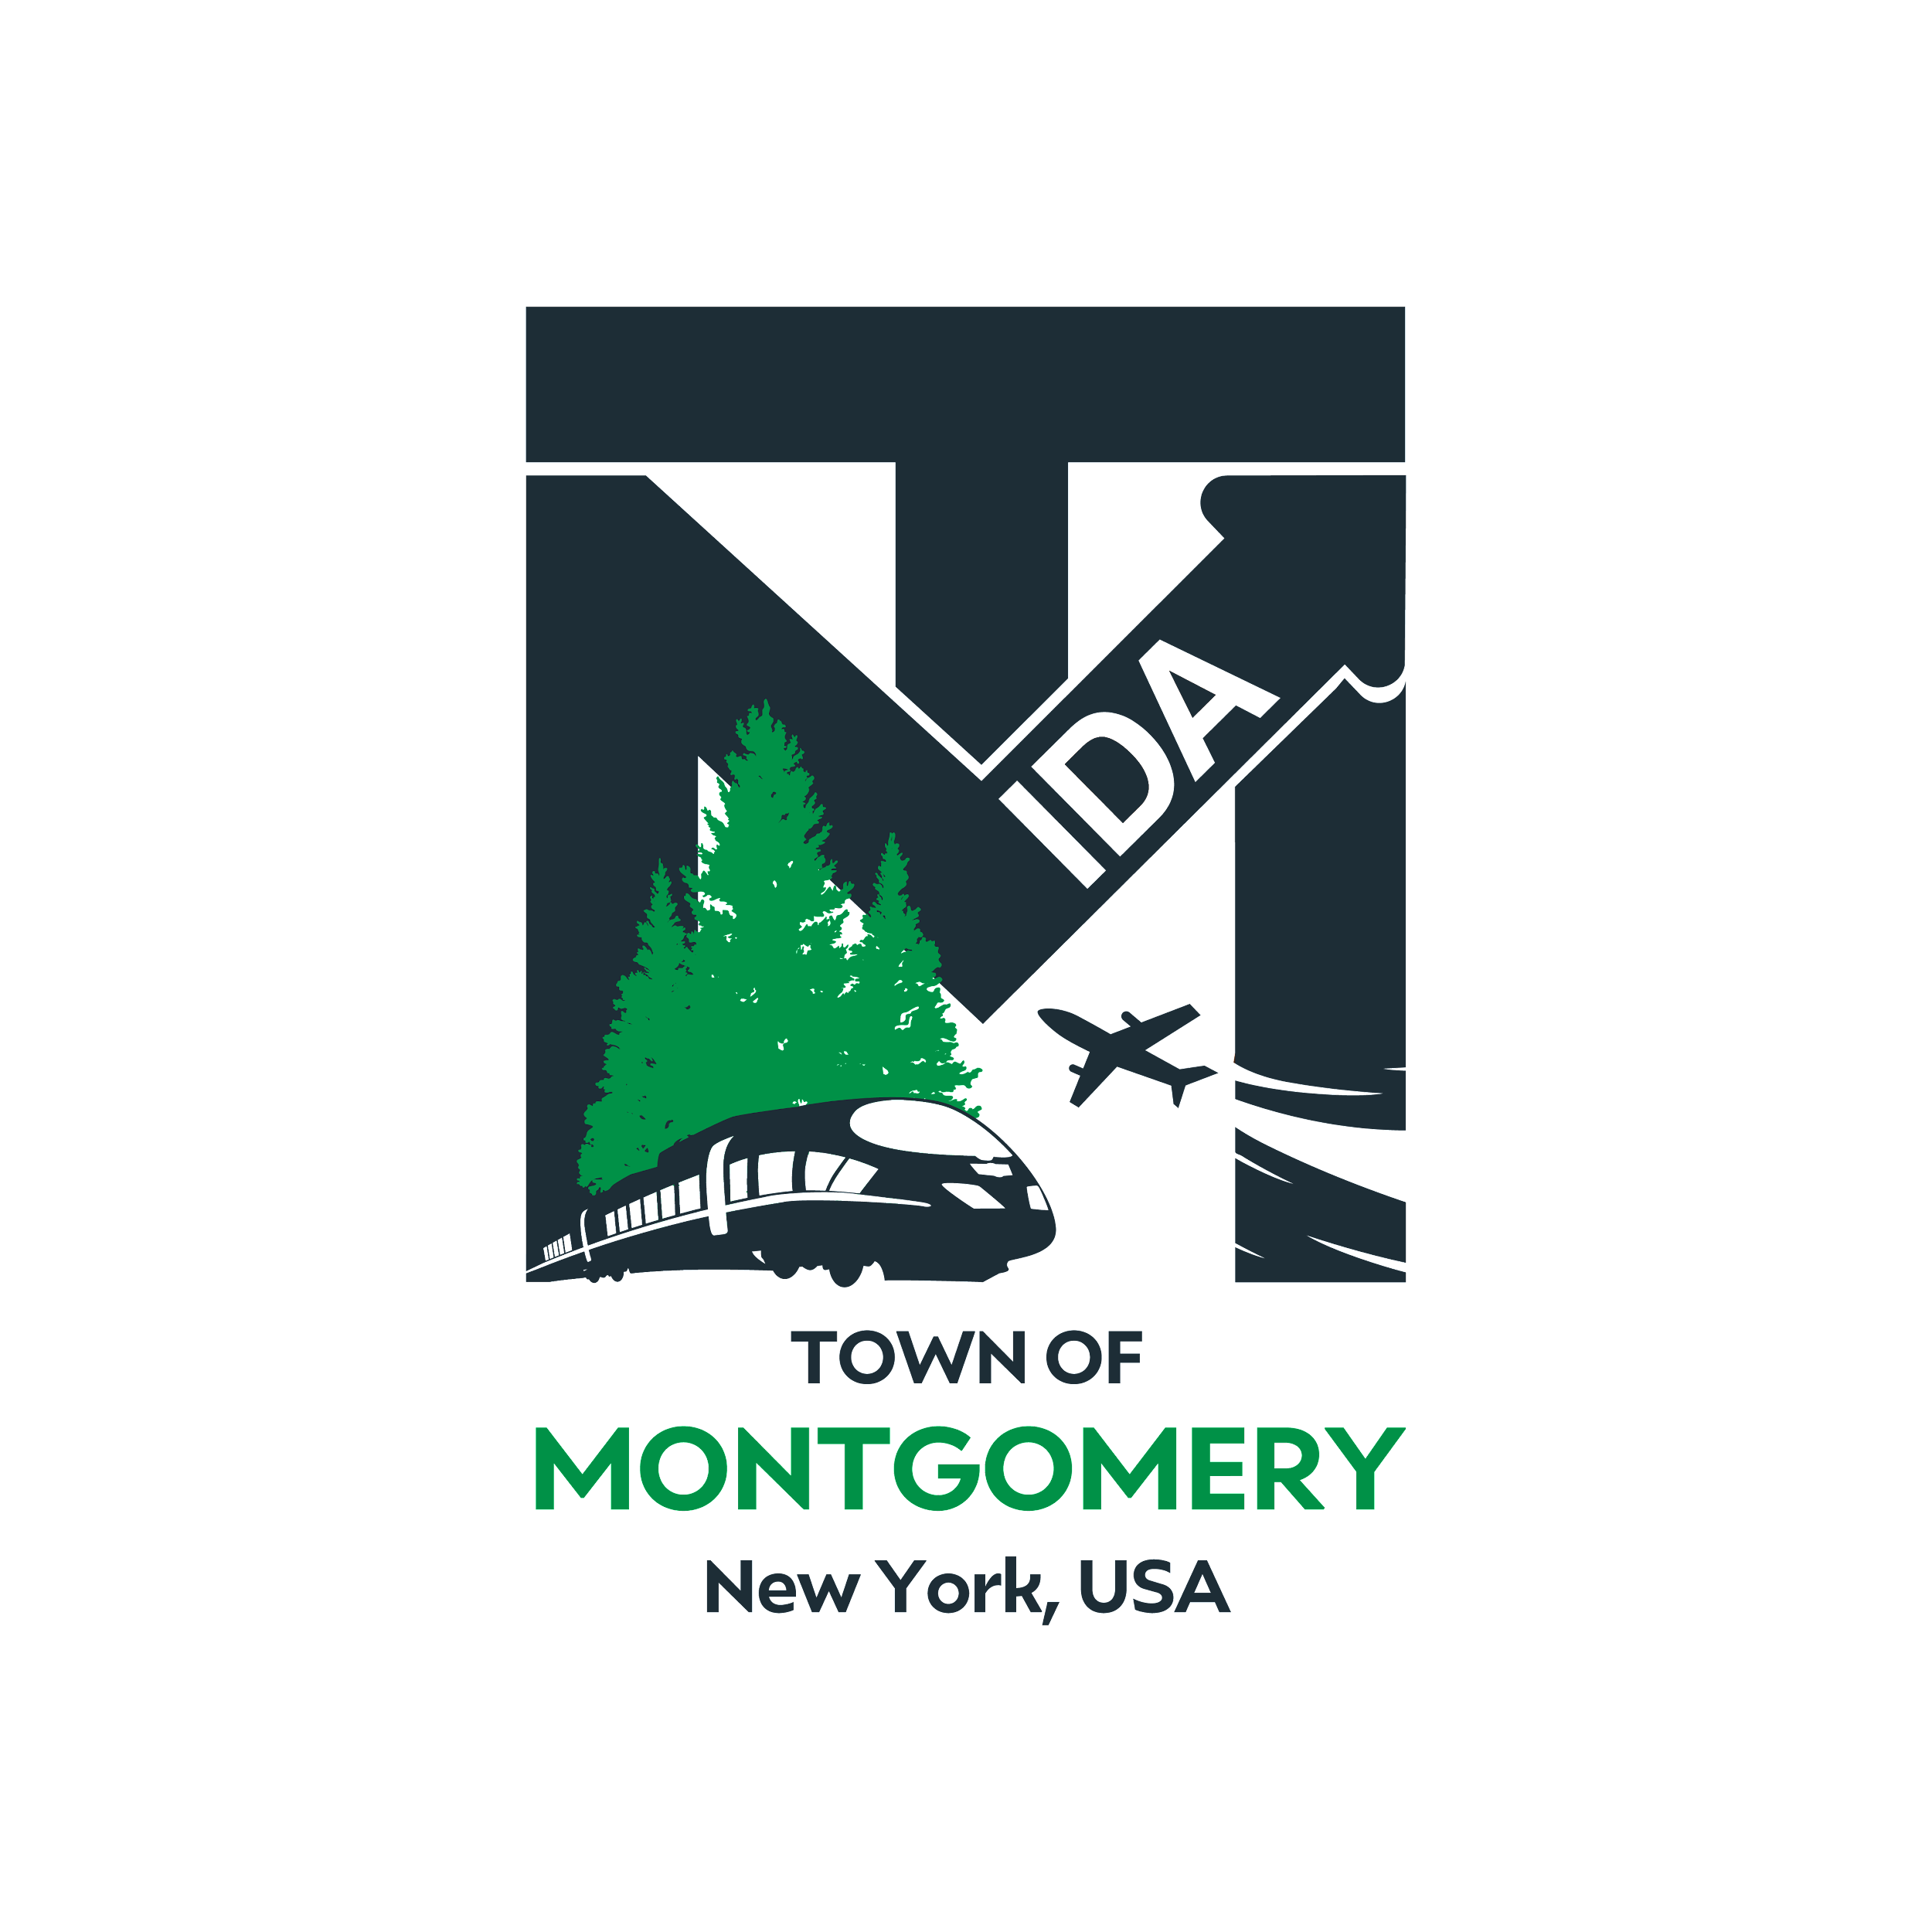
Draft Agenda Subject to Change
REGULAR MEETING OF THE
TOWN OF MONTGOMERY INDUSTRIAL DEVELOPMENT AGENCY
110 Bracken Road
Montgomery, New York 12549
www.montgomeryida.com
(845) 457-2600
Tuesday, May 10, 2022

AGENDA
1:00 PM
- Call to Order and Declaration of Quorum
- Approval of the March 8th, March 22nd and March 30th, 2022 Meeting Minutes
- Public Comment on Items on the Agenda
- Discussion – Financial Report Update
- Other Business – Law Firm Update
- Discussion on Executive Director Search
- Adjournment
- Next Meeting Scheduled for June 13, 2022

The meeting shall be live-streamed and be available for viewing at the following sites: https://acquisitionsmarketing.com/
https://www.facebook.com/TownofMontgomeryOfficial/

