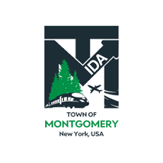

REGULAR MEETING OF THE TOWN OF MONTGOMERY INDUSTRIAL DEVELOPMENT AGENCY
TO BE HELD AT 1:00 P.M. ON TUESDAY, OCTOBER 21, 2022
TOWN HALL
110 BRACKEN ROAD MONTGOMERY, NY 12549

DRAFT AGENDA
Tuesday, October 21, 2022

Order of Business

1:00 PM

- Call to Order and Declaration of Quorum
- Approval of August 16, 2022 and September 12, 2022 Meeting Minutes
- Public Comment on Agenda Items
- Project Updates

- Milk Factory, LLC- Discussion & Project Update
- KCE NY 2, LLC- Project Update & November Public Hearing Confirmation

- 2023 Montgomery IDA Budget Discussion & Vote for Approval

- Executive Director Report

- Financial Report Update as of September 30, 2022

Other Business

Request for Deed Transfer Update-194 Neeleytown Road
- 2022 EDC Fall IDA Academy – November 10, 9:00am-4:30 p.m. at Delta Hotels by Marriott, 200 Genesee Street, Utica, NY

- Adjournment
- Next Regular Meeting Scheduled for Wednesday, November 9, 2022
The meeting shall be live-streamed and be available for viewing at the following sites:

https://acquisitionsmarketing.com/

https://www.facebook.com/TownofMontgomeryOfficial/

Draft Agenda Subject to Change

