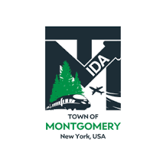

SPECIAL MEETING OF THE TOWN OF MONTGOMERY INDUSTRIAL DEVELOPMENT AGENCY TO BE HELD AT 1:00 P.M. ON MONDAY, SEPTEMBER 12, 2022
TOWN COURT
110 BRACKEN ROAD MONTGOMERY, NY 12549

AGENDA
Monday, September 12 2022

Order of Business

1:00 PM

- Call to Order and Declaration of Quorum
- Approval of August 16, 2022 Meeting Minutes
- Public Comment on Items on the Agenda
- New Projects
- Milk Factory, LLC
  - Introduction & Overview
- KCE NY2, LLC Discussion and Consideration of Public Resolution
- Executive Director Report
- Financial Report Update as of August 31, 2022
- Other Business
- 2022 Economic Development Summit at SUNY Orange Friday, September 30, 2022 8:30 AM - 1:00 PM EST (Middletown, NY)

- Board & Staff Training Day by the Economic Development Council on Thursday, November 10, 2022 (Utica, New York)

- Orange County Board of Ethics 2021 Disclosure Forms

- Adjournment
- Next Meeting Scheduled for Tuesday, October 11 2022 at 1:00 p.m.
The meeting shall be live-streamed and be available for viewing at the following sites:

https://acquisitionsmarketing.com/

https://www.facebook.com/TownofMontgomeryOfficial/

Draft Agenda Subject to Change

