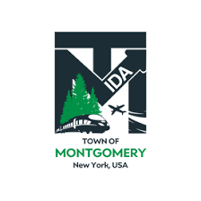

REGULAR MEETING OF THE TOWN OF MONTGOMERY INDUSTRIAL DEVELOPMENT AGENCY
TO BE HELD ON TUESDAY DECEMBER 13, 2022
TOWN HALL
110 BRACKEN ROAD MONTGOMERY, NY 12549

AGENDA
Tuesday, December 13, 2022

Order of Business

1:00 PM

- Call to Order and Declaration of Quorum
- Approval of November 9, 2022 Meeting Minutes
- Public Comment of Items on the Agenda
- Public Hearing- KCE NY 2, LLC

- Public Hearing- Milk Factory, LLC

- Consideration for Approval of Executive Director Town of Montgomery Contract

- Executive Director Report

- Financial Report Update as of November 30, 2022

- Other Business
  - UTEP Policy/Mission Statements Review Discussion for 1-10-23 Vote
  - Consideration of Vote on MIDA Board Meeting & Committee Meeting Dates for 2023
- Executive Session Discussion regarding MIDA Secretary Vacancy beginning December 15, 2022

- Adjournment
- Next Meeting Scheduled for January 10, 2023
The meeting shall be live-streamed and be available for viewing at the following sites:

https://acquisitionsmarketing.com/

https://www.facebook.com/TownofMontgomeryOfficial/

Draft Agenda Subject to Change

