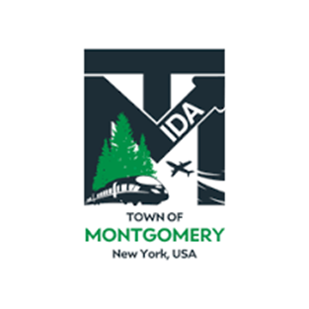

***REGULAR MEETING OF THE***

***TOWN OF MONTGOMERY INDUSTRIAL DEVELOPMENT AGENCY***

*110 Bracken Road*

*Montgomery, New York 12549*

*www.montgomeryida.com*

*(845) 457-2600*

*October 8, 2024*

AGENDA (***\*Draft Agenda Subject to Change )***

1:00 PM

1. Call to Order and Declaration of Quorum
2. Approval of the September 10, 2024 Meeting Minutes
3. Public Comment on Items on the Agenda
4. Milk Factory, LLC- Update
5. Executive Director’s Report
6. Financial Report
7. Other Business
   1. Approval of Finance Committee’s Proposed 2025 Budget
8. Adjournment
9. Next Regular Meeting Scheduled for November 8, 2024 at 1:00 p.m.

The meeting shall be live-streamed and be available for viewing at the following sites: https://acquisitionsmarketing.com/

<https://www.facebook.com/TownofMontgomeryOfficial/>