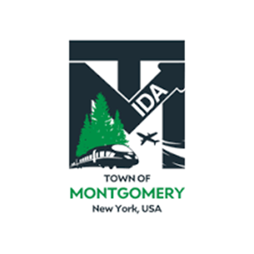

***REGULAR MEETING OF THE***

***TOWN OF MONTGOMERY INDUSTRIAL DEVELOPMENT AGENCY***

*110 Bracken Road*

*Montgomery, New York 12549*

*www.montgomeryida.com*

*(845) 457-2600*

*December 10, 2024*

AGENDA (***\*Draft Agenda Subject to Change )***

1:00 PM

1. Call to Order and Declaration of Quorum
2. Approval of the November 12, 2024 Meeting Minutes
3. Public Comment on Items on the Agenda
4. Executive Director’s Report
5. Milk Factory- Closing Fee Payment Plan
6. Financial Report
7. Procurement Request Discussion and Consideration for Approval
   1. New York State EDC Annual Membership
8. Other Business
   1. Adopt 2025 Board Meeting Schedule/Committee Meeting Schedules
   2. Review UTEP/Mission Statement for January Vote
9. Adjournment
10. Next Regular Meeting Scheduled for January 14, 2025 at 1:00 p.m.

The meeting shall be live-streamed and be available for viewing at the following sites: https://acquisitionsmarketing.com/

<https://www.facebook.com/TownofMontgomeryOfficial/>