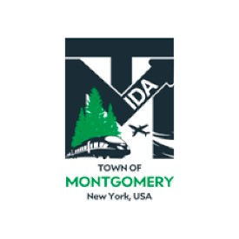

**AUDIT COMMITTEE MEETING**

**TOWN OF MONTGOMERY INDUSTRIAL DEVELOPMENT AGENCY**

# TO BE HELD AT 12:30 PM ON TUESDAY DECEMBER 10, 2024

# TOWN HALL

# 110 BRACKEN ROAD MONTGOMERY, NY 12549

**AGENDA**

*Tuesday, December 10, 2024*

**Audit Committee**

**Order of Business**

**12:30**

* **Call to Order and Declaration of Quorum**
* **Approval of January 2024 Meeting Minutes**
* **Review PKF O’Connor Davies Letter of Engagement for 2024 Audit**
* **Review of 2025 Projected Budget, Change in Net Asset, December Financial Statement and Recommendations Discussion**
* **Adjournment**

*The next Audit Committee Meeting is Scheduled for Tuesday, December 9, 2025*