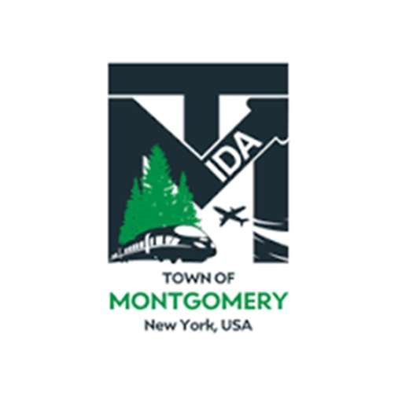
REGULAR MEETING OF THE
TOWN OF MONTGOMERY INDUSTRIAL DEVELOPMENT AGENCY
110 Bracken Road
Montgomery, New York 12549 www.montgomeryida.com
(845) 457-2661

July 8, 2025

AGENDA (*Draft Agenda Subject to Change )
1:00 PM
- Call to Order and Declaration of Quorum
- Approval of the June 10, 2025 Meeting Minutes
- Public Comment on Items on the Agenda
- Executive Director’s Report
- Financial Report
- IDA General Counsel Discussion and RFP for New Counsel
- Other Business
- Adjournment
- Next Regular Meeting Scheduled for August 12, 2025 at 1:00 p.m.
The meeting shall be live-streamed and be available for viewing at the following sites: https://acquisitionsmarketing.com/ https://www.youtube.com/@TownofMontgomeryIDA

