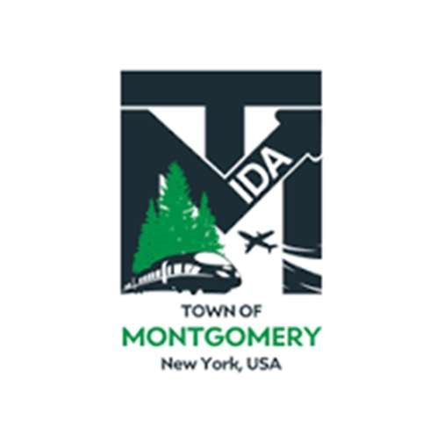
REGULAR MEETING OF THE
TOWN OF MONTGOMERY INDUSTRIAL DEVELOPMENT AGENCY
110 Bracken Road
Montgomery, New York 12549 www.montgomeryida.com
(845) 457-2661

November 12, 2025

AGENDA (*Draft Agenda Subject to Change )
1:00 PM
- Call to Order and Declaration of Quorum
- Approval of the October 14, 2025 Meeting Minutes
- Public Comment on Items on the Agenda
- Executive Director’s Report
- Financial Report
- IDA Term Cycle & Bylaw Amendment Vote
- Other Business
- Executive Session- Review IDA Board Member Applications
- Adjournment
- Next Regular Meeting Scheduled for December 9, 2025 at 1:00 p.m.
The meeting shall be live-streamed and be available for viewing at the following sites: https://acquisitionsmarketing.com/ https://www.youtube.com/@TownofMontgomeryIDA

