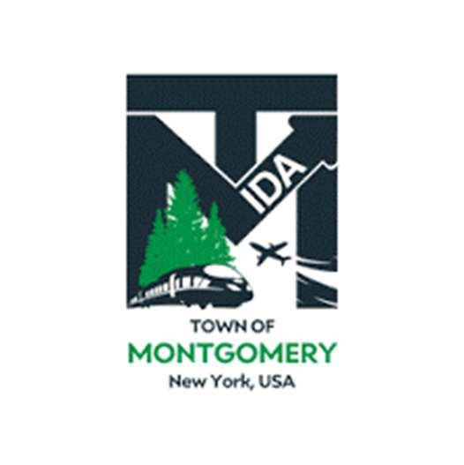
NOTICE OF MEETING CANCELLATION
TOWN OF MONTGOMERY INDUSTRIAL DEVELOPMENT AGENCY

PLEASE TAKE NOTICE that the meeting for the Town of Montgomery Industrial Development Agency has been canceled for Tuesday, July 14, 2026.
The next regular scheduled meeting will be held Tuesday, August 11, 2026 at 1:00 p.m. located at Town Hall, 110 Bracken Road, Montgomery, New York.

Town of Montgomery Industrial Development Agency
Vincent Rouhotas, Executive Director
Dated: July 13, 2026

