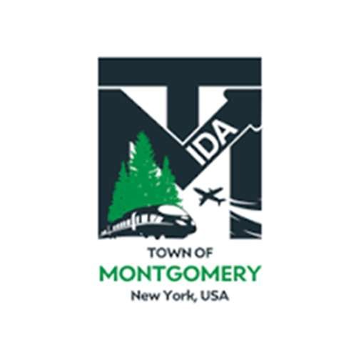
COMMITTEE MEETING OF THE
TOWN OF MONTGOMERY INDUSTRIAL DEVELOPMENT AGENCY
110 Bracken Road
Montgomery, New York 12549 www.montgomeryida.com
(845) 457-2661

August 11, 2026
Finance Committee

AGENDA
12:30 PM
Order of Business
- Call to Order and Declaration of Quorum
- Approval of the August 12, 2025 Meeting Minutes
- Review & Vote Consideration for 2027 Budget & Four-Year Projections
- Adjournment

